October 2022

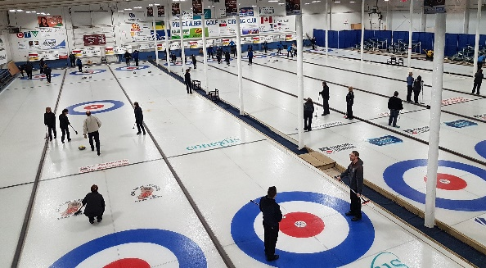
Upcoming Events:
Curling Leagues begin
Afternoon Mixed Oct 17
Ladies, Stick & Econo Oct. 18
Senior Men Oct. 19
Diamond North Thursday Rec Oct. 20
Juniors, 6 Pack & Learn to Curl begin Oct. 24
Doubles League begins Oct. 26
Discover, Try, Learn Oct. 30 – 1:00 pm
2022 Canadian Mixed Curling Championships Nov. 6 - 12
PAG&CC AGM Nov. 23
High Noon Optimist Junior Program & the Adult Learn to Curl program are looking of a few more volunteers to help deliver these programs. If you have time to help, contact Pat Bibby 306-961-5353.

Volunteers of the Month
All the volunteers who have been helping clean the rink & install the ice.
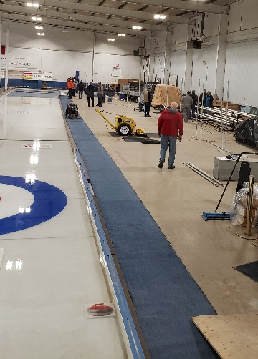
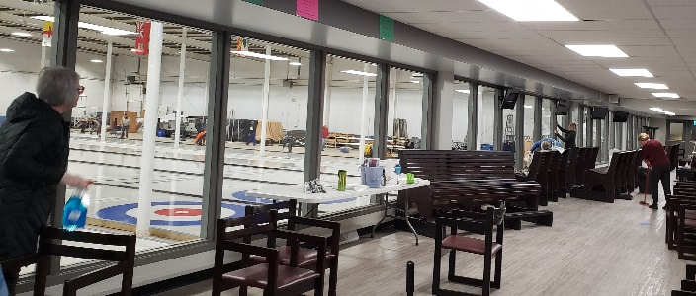

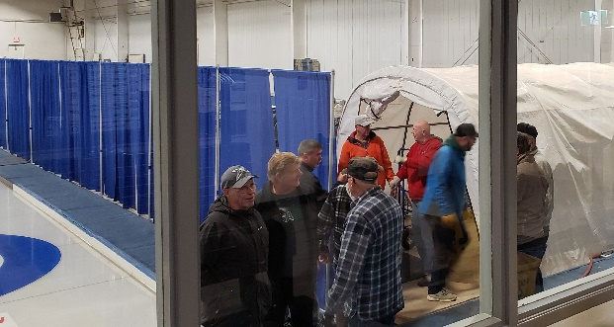

Sponsor of the Month- Overhead Door
Thank you for the installation of the overhead door in the ice area
Much Appreciated

2022 Canadian Mixed Curling Championships
Sunday, November 6 – Saturday, November 12

The Host Committee would like to thank the following sponsors for the event

City of Prince Albert Destination Marketing
Saskatchewan Tourism
Saskatchewan Lotteries/Sask Sport
Northern Lights Development Corporation
Signature Development
BTR Financial
Diamond North Credit Union
Mont St Joseph Foundation
Thierman Financial
Lake Country Co-op
SGI
Great West
Plyr

Congratulations to golfers who had a Hole in One
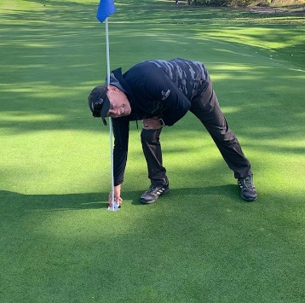
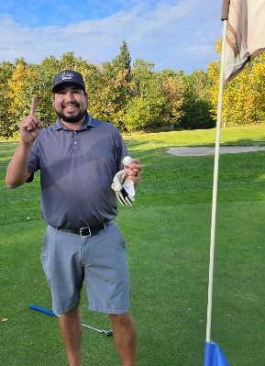
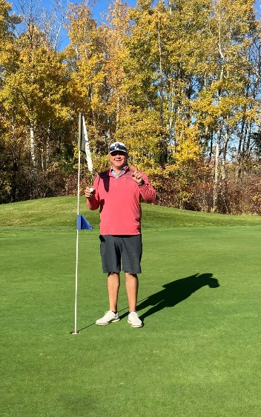

Blayne Nelson Cody Burns Jeff Whitfield
Oct. 3 - #4 Sept. 25 - #17 Oct 10 - #12

Cooke Municipal Wednesday Ladies Golf Club
Our Wednesday Ladies had their windup supper this week. Club Championship trophy was presented to this year's winner Pauline McDougall by Dawn Macauley.
Flight winners:
1st Flight - Dawn Macauley
2nd Flight - Carole Rucks
3rd Flight - Sandra Isbister
4th Flight - Donna Dyck
5th Flight - Kathy Petruk
We would also like to thank Andrea Ring and the Northern Committee and Cathy Pollock for donating door prizes for Wednesday night. The table decorations and table favors were made and donated by Pauline McDougall. The tables looked awesome!! And of course a big thank you to the Rock and Iron staff for the meal and service, outstanding!!

Members receive 10% off their meals & drinks.

Open Monday to Friday 11:00 am – 11:00 pm
Saturday 9:00 am – 11:00 pm
Sunday – 9:00 am – 8:00 pm

Highlights from Board Meeting:
- Minutes of the Board meetings are available to members from the Office or any Board Member.
- Curling registration – online at www.pagcc.ca & at curling office
  - Payment by etransfer to pagcc@sasktel.net or in person debt/credit card, cheque or cash
- AGM – November 23 – Election of officers –Consider letting your name stand for a director on the Board.

Feel free to contact any of the Board of Directors with suggestions, to volunteer for committees or events, express concerns or ask questions:
President Mel Kelley Vice President Dana Dirks
Secretary Sandy Keating Treasurer Don Filteau
Directors Ken Newman Pat Bibby Donna Thorsen
Brett Blakely Tyler Harrison Lindsay Baker
Norm Vetter Guy Mounce
General Manager – Darcy Myers Office Manager – Suzi Klughart – 306-765-5201 Bookkeeper – Bobbi Bell

Thank you to
PAG&CC SPONSORS

River Breeze Retirement Complex

